

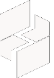

MICROSOFT ARCHITECTURE BEST PRACTICE FOR SECURITY
USECASE: ACCESSING MULTITENANT WEB APPLICATIONS HOSTED ON AZURE FROM ON-PREMISES ENVIRONMENTS

Document Title | Microsoft Cloud Center of Excellence Overview
Presales/Technical Head | Tushar Mehrotra/Rohit Pandey
CCoE Lead | Ravishankar N
Creation Date | August 2025
Version | Description | Modified by | Date | Approved by | Date
1 | Initial Architecture design | AJEET KUMAR | 07/08/2025 | Ravi Shankar | 07/08/2025
2 | Reusability & scalability | AJEET KUMAR | 13/08/2025 | Ravi Shankar | 13/08/2025
Contents
1
1. Executive Summary 3
2. Scope and Applicability 3
3. Business Scenario Overview 3
4. Reference Architecture Overview 4
4.1 Architecture Description 4
5. Logical Architecture Components 4
5.1 Multitenant Web Application Layer 4
5.2 Networking and Connectivity Layer 4
5.3 Private Access and Endpoint Layer 5
5.4 On-Premises Integration Layer 5
5.5 DNS and Name Resolution 5
5.6 Security and Governance Controls 5
6. Cloud Center of Excellence (CCoE) Enablement Model 5
7. Reusability and Scalability 5
8. Conclusion 6

1. Executive Summary
This document is based on accessing multitenant web applications hosted on Azure from on-premises environments. The architecture enables private, secure, and reliable connectivity without exposing applications to the public internet.
The solution aligns with Microsoft principles of Zero Trust, secure by design, and defense in depth.

2. Scope and Applicability
This reference architecture applies to:
- Multitenant web applications hosted on Azure App Service or Azure Functions
- On-premises users requiring private access to Azure-hosted applications
- Enterprises with strict security, compliance, or data residency requirements
- Hub-and-spoke networking models with centralized connectivity
- CSP, enterprise IT, and CCoE governed Azure platforms
The architecture prioritizes private connectivity and isolation over public internet exposure.

3. Business Scenario Overview
Organizations operating multitenant web applications often require employees or partners in on-premises networks to access these applications securely. Publishing applications over public endpoints increases exposure to threats such as:
- Unauthorized access attempts
- Data exfiltration risks
- Compliance violations
This architecture enables private access over VPN or ExpressRoute, ensuring that traffic remains on trusted networks while maintaining tenant isolation for multitenant applications.

4. Reference Architecture Overview
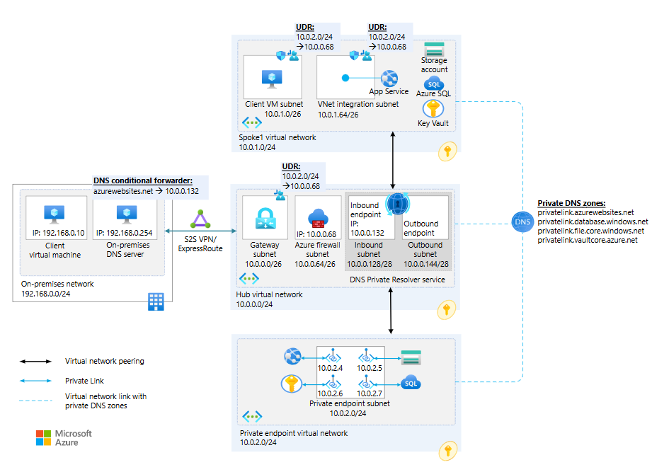

4.1 Architecture Description
The solution implements a private connectivity model where multitenant web applications are accessed through:
- Azure Virtual Network (VNet) integration
- Azure Private Link and private endpoints
- Secure on-premises to Azure connectivity
This approach removes dependency on public internet routing and enforces strict access control policies.

5. Logical Architecture Components

5.1 Multitenant Web Application Layer
- Azure App Service (Basic, Standard, or Premium tiers)
- Shared application hosting model with tenant isolation at the application layer
- Support for SaaS and internal multitenant applications
This layer hosts the multitenant application logic.

5.2 Networking and Connectivity Layer
- Azure Virtual Network (VNet) integration
- Hub-and-spoke network topology
- Centralized connectivity services
This layer provides controlled network routing and segmentation.

5.3 Private Access and Endpoint Layer
- Azure Private Link
- Private endpoints for App Service and dependent PaaS services
- Dedicated private endpoint subnets
Private endpoints ensure traffic remains within the Azure backbone network.

5.4 On-Premises Integration Layer
- Site-to-Site VPN or Azure ExpressRoute
- Encrypted private connectivity between on-premises and Azure
This enables secure application access without public exposure.

5.5 DNS and Name Resolution
- Azure Private DNS Zones
- Conditional forwarding from on-premises DNS to Azure DNS Private Resolver
- Name resolution for private endpoints
Proper DNS configuration ensures seamless private access.

5.6 Security and Governance Controls
- Microsoft Entra ID for authentication and authorization
- Network Security Groups (NSGs)
- Azure Policy and monitoring controls
Security policies ensure consistent enforcement across tenants.
Continuous monitoring and security validation are enforced throughout the solution lifecycle.

6. Cloud Center of Excellence (CCoE) Enablement Model
The CCoE uses this architecture to:
- Define standardized patterns for private application access
- Enforce enterprise networking and security standards
- Provide reusable landing zone connectivity architecture

7. Reusability and Scalability
- Reusable across multiple multitenant applications
- Scales to support increasing tenant and user counts
- Compatible with hub-and-spoke and enterprise-scale Azure landing zones

8. Conclusion
The Access Multitenant Web Application from On-Premises Reference Architecture provides a secure, Microsoft-aligned solution for enabling private access to multitenant Azure web applications. By eliminating public exposure and enforcing private connectivity, organizations can meet security, compliance, and operational requirements at scale.

